ATMOCARE HOMEPAGE DESIGN SECTION
1. Hero Banner
- Top Header : About Us| Clients |Contact|
ATMOCARE Logo
Category Navigation: Displays the primary categories in a horizontal row.
Home |Scent solutions|Aromatic oils|Scent Contracting|Bestseller|Sale|Shop all|
Right side: Search | Cart |
Full-width video/image banner
- Heading: Transform Your Space Through Scent
- SubHeading:
Discover premium fragrances and scenting solutions designed to create inviting and memorable spaces.
- CTA
Shop Now | Explore Scent Solutions
- Sticky icons: whatsapp | email | cart
____________________________________________________________
2. Our Products(Suggestion In this site third section)
https://preview.themeforest.net/item/neriva-beauty-skincare-woocommerce-theme/full_screen_preview/65107819
- Categories
i) Scent Solutions
Diffusers and related scenting products.
ii) Aromatic Oils
Fragrances and aromatic oils available for different scenting requirements.
iii) Scent Contracting
Professional scenting solutions for businesses and commercial spaces.
- CTA : Explore Product
____________________________________________________________
3. Best Sellers
- Heading: Our Best Sellers
- Content : Discover the fragrances loved by our customers. Explore our most popular scents, carefully selected to add a touch of luxury and elegance to every moment.
Display approximately 4–6 popular products Image card with:
- Best seller Badge (top on the each image right side) & Wishlist icon
- Product image
- Product name
- Fragrance/type
- Price
- Product rating/review
- Add to Cart
- View
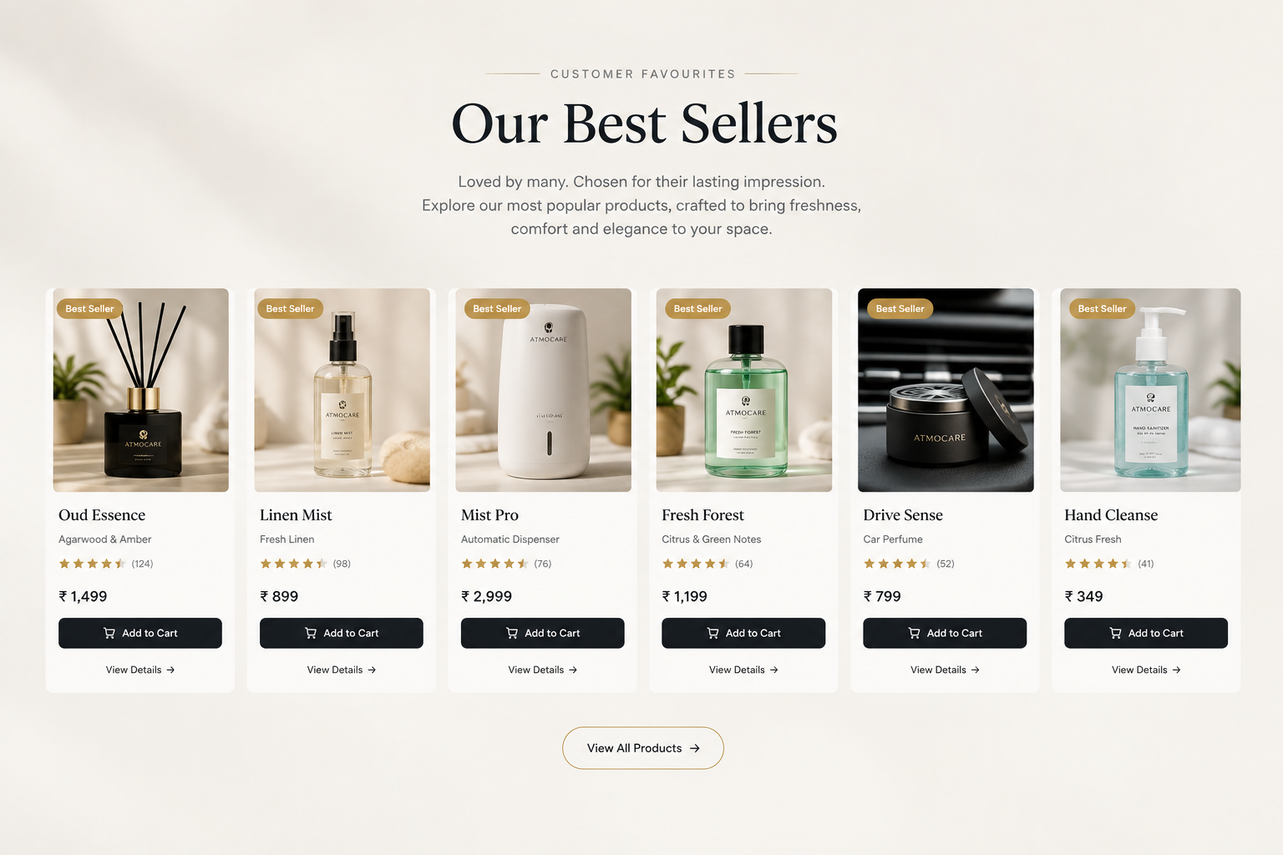
4.Promotional Banner
Heading:Elevate Your Space with the Perfect Scent
Content:Discover our specially curated scenting essentials and enjoy exclusive
offers designed to bring a luxurious fragrance experience to your space.
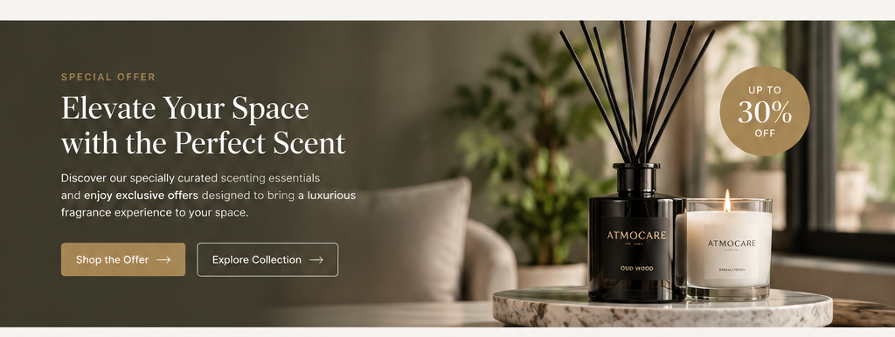
____________________________________________________________
5. Featured Products
- Heading:Featured from Atmocare
- Content : Explore our specially selected fragrances, crafted to bring elegance, freshness, and a lasting impression to every occasion.
Highlight selected Atmocare products such as:
- Featured diffusers
- Signature fragrances
- New products
- Premium products
- Seasonal products
Product Information
- Product image
- Wishlist icon
- Product name
- Short description
- Price
- View Details
- Add to Cart
____________________________________________________________
6. About Atmocare
- Image (Automatic Sliding Images or manuel)
- Heading: Creating Better Spaces Through Scent
- Content:
Atmocare specializes in Scent, Hygiene, and Industrial Product Solutions, offering tailored products and services for businesses and commercial spaces. With over a decade of industry experience, Atmocare focuses on delivering reliable solutions that enhance spaces and customer experiences.
- USP’s
Title : We have three divisions
i) Aroma Solutions
ii)Hygiene Solutions
iii)Industrial Products Supply
CTA: View More
____________________________________________________________
7. Why Choose Atmocare?
- Title : Why Choose Atmocare
- Content : More than just fragrance—we create experiences that inspire, spaces that connect, and solutions you can trust. With expertise, innovation, and a commitment to quality, Atmocare brings the right scent, hygiene, and industrial solutions to every environment.
Highlight (Using Images)
- Premium Fragrance Solutions
High-quality fragrances created to deliver a refined and lasting experience.
- Professional Scenting Expertise
Expertly developed scenting solutions for homes, businesses, and commercial spaces.
- Solutions for Every Space
Tailored fragrance options designed to suit different environments and requirements.
- Wide Product Selection
Explore a diverse range of fragrances, diffusers, and scenting products for every preference.
- Dedicated Customer Support
Friendly guidance and reliable support to help you choose the right fragrance solution.
____________________________________________________________
Title (center) : Recipients of ATMOCARE Contact Now
Redesign : Single row automatic sliding the recipients logos & names
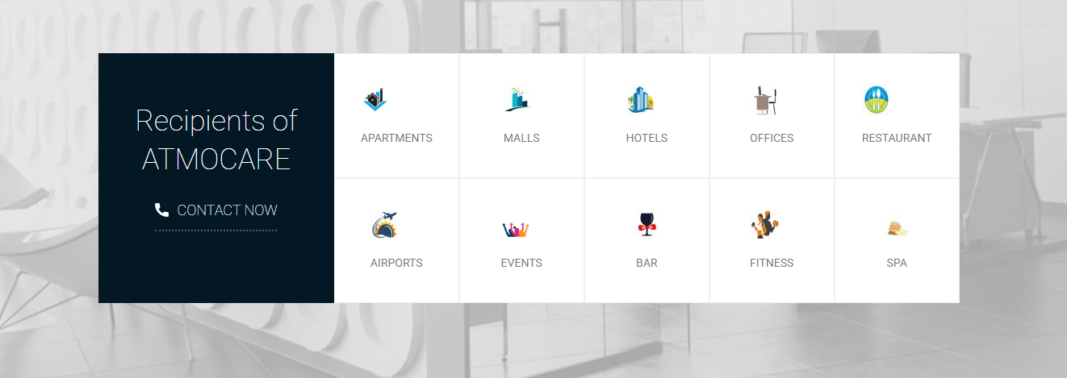
____________________________________________________
8. Customer Testimonials
Content
3–4 verified testimonials from existing customers.
Each testimonial can include:
- Customer/company name
- Short testimonial
- Designation/company
- Optional image/logo
____________________________________________________________
9. Our Clients
Heading:Our clients
Sub heading:Crafting Success Stories with Our Elite Clientele
Display verified client logos
Suggestion:
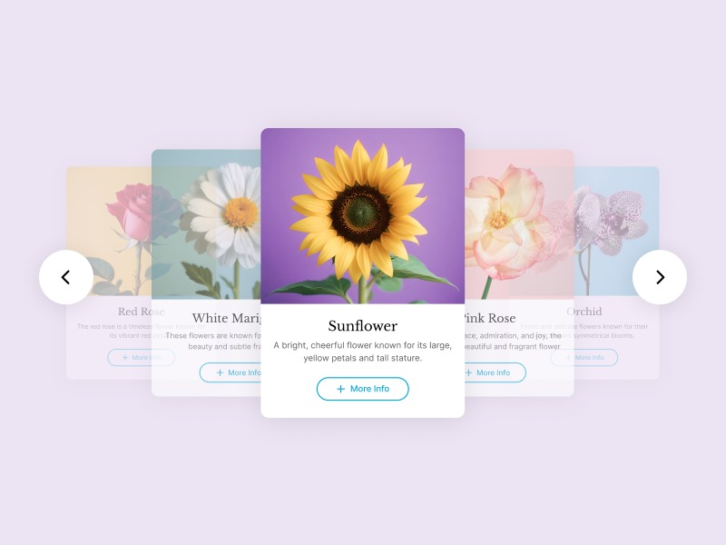____________________________________________________________10. Blog
Heading:Explore the World of Scent
Content
- How to Choose the Right Diffuser
- How to Choose a Fragrance
- Which Scent Is Right for Your Space?
- How Long Does Fragrance Oil Last?
- Home Scenting Guide
- Commercial Scenting Guide
CTA:Explore the Scent Guide
_______________________________________________________

11. Final CTA
Heading:Find the Scent That Belongs in Your Space
Subheading
Explore our collection of diffusers, fragrances and scenting solutions for homes, businesses and commercial spaces.
CTA:Shop Now
_______________________________________________________

12.Footer Structure
1. About Atmocare
- About Us
- Clients
2. Quick Links
- Home
- Shop
- products
- Blog
- Contact Us
- Wishlist
- Cart
3. Customer Support
- Privacy Policy
- Terms & Conditions
4. Contact Us
- Address
- Phone
- Email
5. Social Media
Instagram | Facebook | LinkedIn | YouTube
Privacy Policy | Terms & Conditions | Shipping Policy |

Client side reference:
https://aroma-247.com/
https://aeromaoneplus.com/
https://scentscircle.com/
https://www.evodiaperfumes.com/
Our side Reference:
https://arrax-preview.myshopify.com/
https://seraphina.qodeinteractive.com/perfumes-home/
https://iscent.com/

